zCP1402CP5631 - Addressing Review

1. For each of the following addresses, first identify whether the address is valid. If it is valid, identify the class of the address (A, B, C or D) and whether it is public or private. If it is invalid, explain why.
2. 192.168.0.1 Valid, Class C, private
3. 227.189.64.77 Valid, Class D, public
4. 88.88.88.88 Valid, Class A, public
5. 177.29.187.77 Valid, Class B, public
6. 134.72.90.1 Valid, Class B, public
7. 200.257.38.40 Invalid.
8. 172.30.99.255 Valid, Class B, private
9. 190.104.78.2 Valid, Class B, public
10. 10.255.0.0 Valid, Class A, private
11. 15.255.255.36 Valid, Class A, public
12. How many bits in a MAC address? What are the two parts of a MAC address?

1 - MAC addresses are 48 bits long.

2 - A MAC address consists of two parts: a 24-bit organizationally unique identifier (OUI)

and a 24-bit device identifier.

1. **True or false:** In order to communicate across the internet, two nodes need to know each other’s MAC address.

False.

A device must know the destination MAC address to communicate locally through ethernet or traced on a network that it's still connected to.

1. How many bits in an IPv4 address? How many different IPv4 addresses are possible?  
   IPv4 address is 32 bits in length.

4,294,967,296 IPv4 addresses are possible.

1. How many bits in an IPv6 address?

IPv6 address is 128 bits in length.

1. What is the purpose of port numbers? How many port numbers are there?

1 - Port numbers are used to identify specific applications or services on a computer, and they allow data to be delivered to the correct destination when it is received over the internet or a local network.

2 - The number of port numbers available depends on the transport protocol being used.   
There are **65,535 port numbers**, but not all are used every day. Restricted port numbers or well-known port numbers are reserved by prominent companies and range from 0 to 1023.

1. To what layer of the OSI model does each of the follow address types belong? Justify your answer.
   1. IP address network layer, level 3
   2. MAC address data link layer, level 2
   3. Fully qualified domain name (FQDN) application layer
2. Describe the role of the following types of DNS servers:
   1. Root server

Root DNS servers hold information used to locate top-level domain (TLD) servers

* 1. TLD server

TLD servers in facilitating the DNS lookup process by providing the DNS records that enable the mapping of domain names to their corresponding IP addresses.

* 1. Authoritative server

Authoritative name server is the authority on computer names and their IP addresses for computers in their domains.

1. For the address **[www.google.com](http://www.google.com)**, match the parts of the address to their roles:  
    **www** top-level domain (TLD)

**google.com** hostname

**.com** domain name

1. What happens when you ping 127.0.0.1?

This IP address known as the loopback address.

Test the reachability of the host on 127.0.0.1 and measure the round-trip time fro messages sent form the host the the destination.

64 bytes from 127.0.0.1: icmp_seq=0 ttl=64 time=0.043 ms

1. What command-line tool can you use to quickly determine your computer’s IP address?

ipconfig

1. Try the following on the command line. What address do you get in each case? Why are they different?
   1. nslookup google.com

The output of this command will likely be the IP address of a Google server, because the "nslookup" command is used to query DNS servers to obtain the IP address of a specific domain name.

* 1. nslookup google.com 8.8.8.8

Same as above, but in this case the "nslookup" command is explicitly specifying the DNS server to use for the query, which is the Google Public DNS server at "8.8.8.8". This means that the query will be forwarded to the Google Public DNS server, which will provide the IP address of a Google server in response.

* 1. nslookup google.com 1.1.1.1

Same as above, However, in this case the "nslookup" command is specifying a different DNS server to use for the query, which is the Cloudflare DNS server at "1.1.1.1".

The different outputs for these commands are due to the different DNS servers that are being used for the queries. Each DNS server may have different DNS records for the same domain name, and may provide different IP addresses in response to the same query.

Next Page

**Hands-On Activity: Identify a NIC Manufacturer**

Wireshark is a free, open-source network protocol analyser that can help demystify network messages and help make the OSI model a little more tangible for you.

Most of these packets include the MAC addresses of the sender, the receiver, or both. When collecting network data on Wireshark using the default settings, some of the OUIs are automatically resolved, telling you the manufacturer of each device. In Figure below, you can see where Wireshark has identified the manufacturer—Intel—of a laptop NIC on this network.

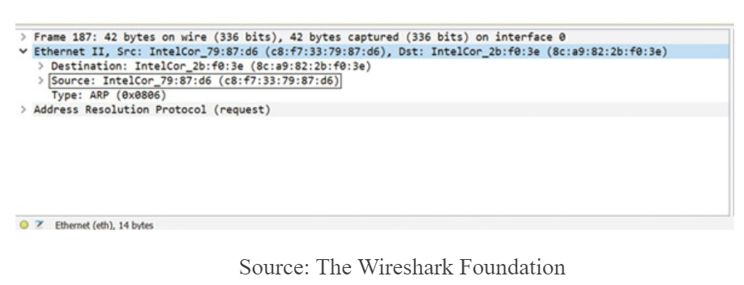

Sometimes, however, you might be working with physical addresses provided by a command output, or you might need a little more information than what is provided by a Wireshark capture. For these situations, use an online MAC address lookup table such as Wireshark’s OUI Lookup Tool.

1. In your browser, go to <https://www.wireshark.org/tools/oui-lookup>. Notice earlier in the figure above that the MAC address of the Source device is located inside the black box. The first three bytes of this address, c8:f7:33, make up the OUI of the device’s manufacturer. Type those numbers into Wireshark’s OUI Lookup Tool and click **Find**. What results did you get?

C8:F7:33 is Intel Corporate

You can perform the same lookup using output from a Command Prompt window:

1. Open a Command Prompt window and enter **ipconfig/all** to identify the NIC’s physical address.
2. To select and copy this information into your Clipboard, first press **Ctrl+M** to enable marking, and then select the first three bytes of the physical address for the active network connection. Press Ctrl+C.
3. Click in the search box on Wireshark’s website, press **Ctrl+V** to paste the information into the Wireshark Lookup Tool, and click **Find**. Who is the manufacturer of your NIC?

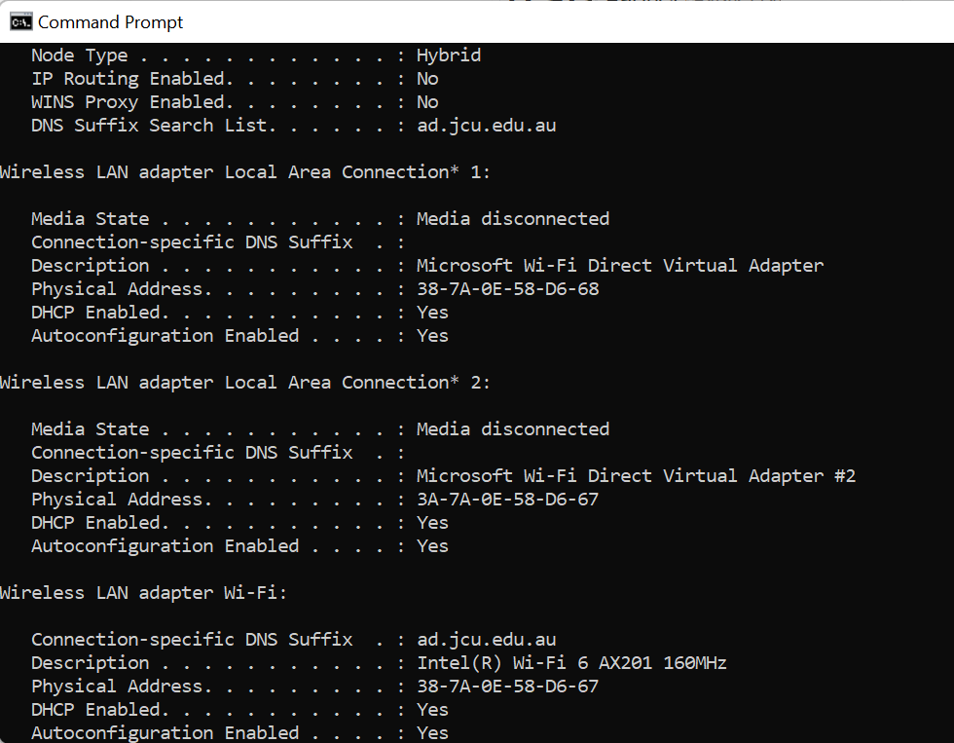 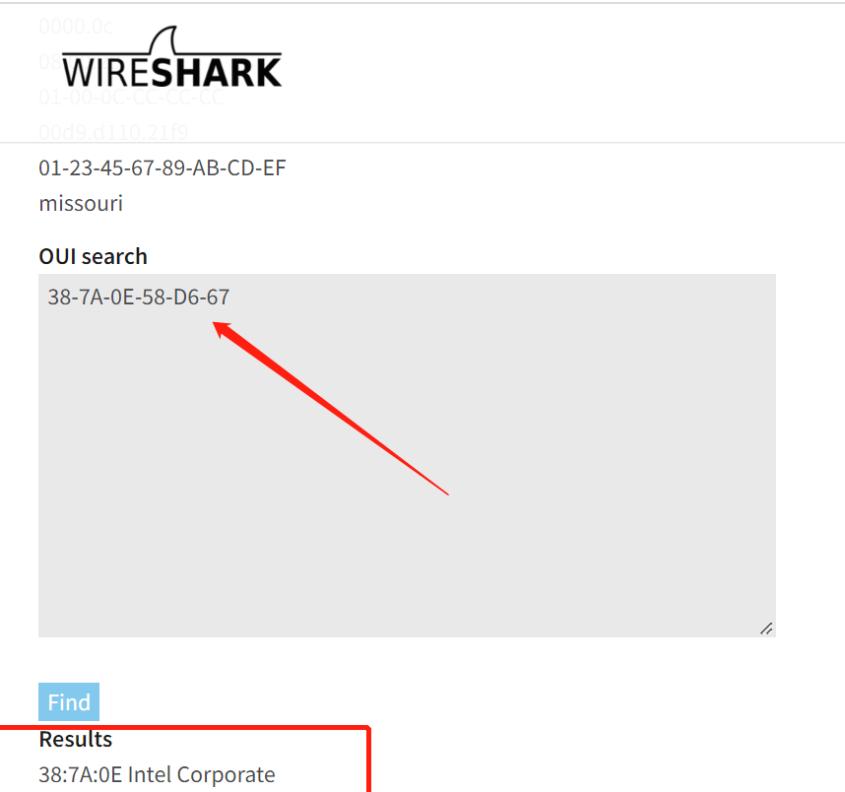

Inter corporate is the manufacturer of my NIC.